TOP 5 REMINGTON PAINTINGS ABOUT WILD WEST
Are you drawn to the wilderness of the American cowboy life or the landscapes that pronounced the Old West? Your search for authentic Remington Oil Paintings could just end here where you can browse the most priced and magnificent artworks of Frederic Remington, a name that vibrates high in the genre and will satiate your thirst for the fine wild west art.

A Master of the Wild West paintings, Frederic Remington, knew how to engross the audience and grip their attention. His artworks have borne a signature imprint of the Wild West that fascinated him ever through his childhood.

Let us explore the wilderness and range of this renowned western artist and find out what are the most exquisite components of his style.

The Distinctiveness of Remington’s Paintings

Frederic Remington’s artworks were a bold embodiment of a great chapter of American history that was marked by the Native Americans, cowboys, bushwhackers, and other dramatic horsemen, etc. A painter extraordinaire, Remington’s work was a vehement manifestation of his romance for the cowboy life.

Never has art known a person so passionate about outdoors, military and horses that became a hallmark of his paintings. His paintings, sculptures and even his illustrations were a stirring portrayal of the adept horsemanship and warfare set against huge expanses of wild landscapes, with impressive accuracy to detail.

The western artist’s artworks were a tribute to the US Army officers as he became skilled at romanticizing the soldiers and horsemen who were his staunch ideals. His paintings have been fuelled by his own experiences during his childhood and hence considered as unique and contemporary.

Most Iconic Paintings of his Career

Of the million pieces of art that are created, there are only a few that can leave an impact and continue to inspire people transcending time and gather appreciation from cognoscenti. It is the authenticity of his expression that his artworks were acknowledged and well-received by people without any age bar and echoing their sentiments.

“I knew the wild riders and the vacant land were about to vanish forever…and the more I considered the subject, the bigger the forever loomed. Without knowing how to do it, I began to record some facts around me, and the more I looked the more the panorama unfolded.”
-Frederic Remington

1. The Cowboy

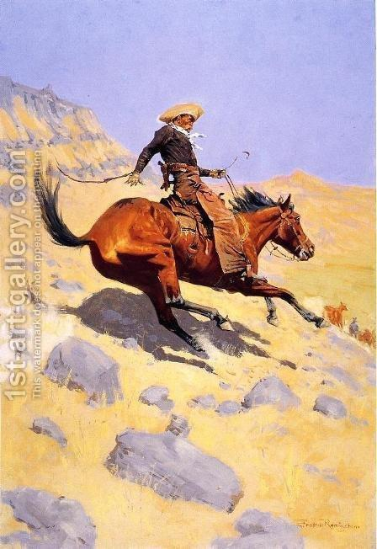

‘The Cowboy’ is regarded as one of the exemplary depictions of the subject and was endowed with his naturalistic style. The Cowboy was a portraiture of his newly found mindfulness of color against a desert landscape.

The cowboy oil painting formed a part of the four of his paintings that had been reproduced in the October issue of Scribner’s Magazine titled “Western Types”. It was after the American Civil War that the cowboy rose to prominence as the romantic hero of the Wild West. Do you know that the works of Remington were highly instrumental in letting the cowboy attain that stature?

2. A Cavalryman’s Breakfast on the Plains

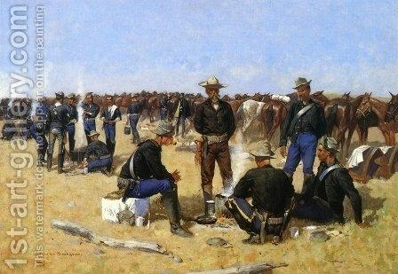

Remington’s career had already reached a peak when ‘A Cavalryman’s Breakfast on the Plains’ was completed. The masterpiece found its motivation in the sharp realism of French military painters.

In fact, for the depiction of soldiers in the fore, Remington took inspiration from one of his earlier compositions. He had by now become the staunchest spokesman for US Cavalry and reforms needed in the infrastructure.

3. A Dash for the Timber

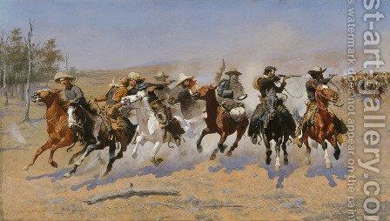
‘A Dash for the Timber’ is viewed as the most notable works of the artist and is presently hung at Fort Worth, Texas. The cowboy oil painting shows eight cowboys desperately galloping towards the plane of the picture. It is also seen that three of them are shooting at the huge group of mounted Indians who are pursuing them.

The title itself explores the chance of escaping into the forest. That’s not all, the painting instills anxiety, fear and leads to that adrenalin gush in the on-looker as one gets to witness a cavalry charge.

4. The Apaches

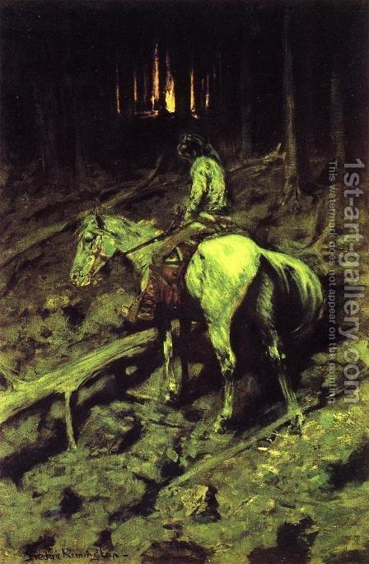

A fine piece of art was painted in 1904 as a response to the continued fascination of the American public of Geronimo, the chief of Apache Indians. It is a vivid representation of the time when a highly frightened cavalryman had brought a piece of horrible news about advancing Apache raiders. The artwork was more sophisticated and had a better sense of color and showed Remington’s development as a true artist.

5. The Last Stand

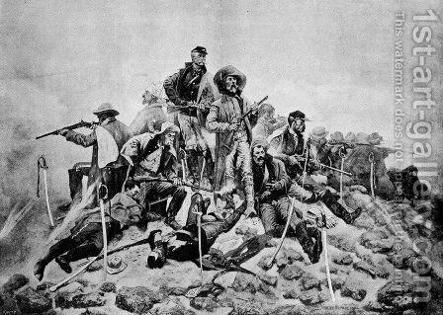

The classic ‘The Last Stand’ painting illustrates the most conclusion of a bear hunt culminated on a range. The hungry dogs have managed to pin the prey as the cowboys take charge to kill the beast. Remington was known to be puzzled by the bears so much as he was always troubled by the presence of other animals apart from horses.

Own the Wild West

Frederic Remington progressed from being a premier chronicler to one of the most revered historian artists whose flair for detail and inspiration from real-life lent a new naturalistic flavor to American art. His contribution to art will be long cherished by generations who will have a rich taste to discover Wild West.

